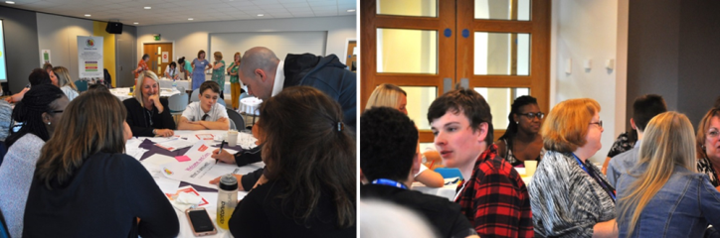

Genuine Partnerships Training Packages

Genuine Partnerships is a nationally recognised Rotherham-based team of parent carers, service practitioners and young people modelling, promoting and strengthening co-production and inclusion through their Four Cornerstones approach.

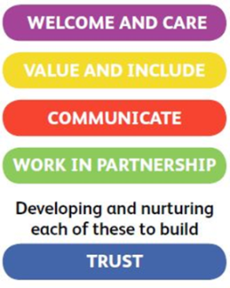

*The Four Cornerstones of*

*Co-production and Inclusive Practice model developed by Genuine Partnerships*

The team’s co-created and interactive training packages are tailor-made to suit organisational and local area needs. Training can be adapted* for practitioners in schools and settings, Health, Education and Care services, parent carers and young people.

Some of our training packages:

Strengthening co-production *Supporting local areas to bring partners together to better understand and implement co-production*

The Listening Package *How we listen: developing the right skills to work effectively in partnership with children, young people and families*

Appreciative Inquiry *Looking for nuggets and helping create heaps of gold: using positive psychology to build on personal and organisational strengths together in order to achieve dreams and agreed goals*

Theo’s story – there’s another side to this! *A case study emphasising the importance of really hearing and responding to the stories young people wish to share*

|  |
| --- |
| *Training Packages*: from £680 per day (dependent on numbers)  Contact Eva for more information:  email genuine.partnerships@rotherham.gov.uk or telephone 01709 822580  Please ask about bespoke training, consultation and project work available. |

This list is not exhaustive! The team is happy to work with you on bespoke training to meet your needs.

*Currently, training is being delivered virtually in response to the COVID 19 pandemic. This will be regularly reviewed with local area partners as restrictions are eased.