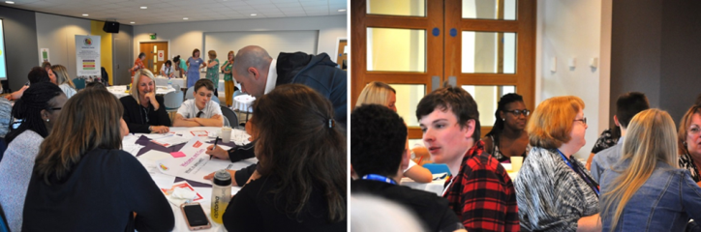

*Strengthening Co-production*

One day interactive programme

Co-production is a particular and empowering way of working, unique to each context, and requires careful nurturing. You can’t simply plant one model of co-production and expect it to thrive, which is why it is so hard to replicate. But you’re not alone. Every local area has a responsibility under section 19 of the Children and Families Act 2014, and in considering their Ofsted / CQC joint Local Area inspection, to face this question.

The great news is that Rotherham-based Genuine Partnerships, together with national delivery partner Contact,can help. The *Strengthening Co-production* one day programme* is based upon the Four Cornerstones of Co-production and is designed to support local areas in bringing all partners together to better understand co-production, evaluate how well they are doing and how they could make the experience even better, introducing tools and guidance that will enable next steps to be planned in more equal partnership.

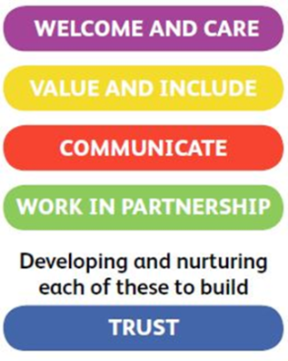

*The Four Cornerstones of*

*Co-production and Inclusive Practice model developed by Genuine Partnerships*

|  |
| --- |
| *Strengthening Co-production*: only £1,280 plus expenses  Your training will be delivered by an experienced parent carer or young person together with a practitioner. We will work in partnership with you to learn more about your local context. We will also offer informal guidance about working together in equal partnership as you are planning your event, and in action planning afterwards.  Please ask about bespoke alternatives, additional support, planning, next steps and *VOICES*.  Contact Eva for more information or to discuss in more detail:  email genuine.partnerships@rotherham.gov.uk or telephone 01709 822580 |

*Currently, Genuine Partnerships’ packages are being delivered virtually in response to the COVID 19 pandemic. This will be regularly reviewed with local area partners as restrictions are eased.