Name of school, setting, service or process/project
Co-production, inclusive practice and wellbeing: How well are we doing?
Inclusive practice is making sure that everyone is included and accepted as an equal.
Co-production is working together on something in equal partnership from the start.
The law says that children and young people with special educational needs and/or disabilities, and their parents and carers, should have all the information and support they need to take part in decisions being made about them. This will give them good experiences and the best outcomes, and support everybody’s wellbeing.
The Four Cornerstones can help us measure how well schools, settings, services and processes are doing:
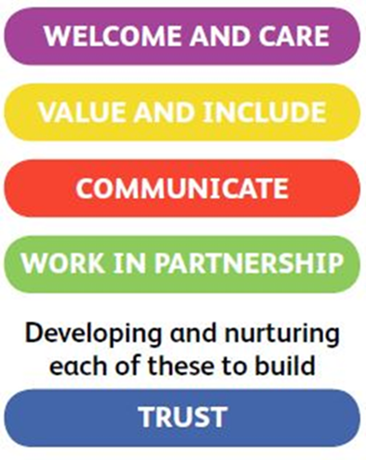
The Cornerstones strengthen trust and create good quality relationships
Choose the number that describes how you feel we are doing for each Cornerstone:
This means that we:

1 2 3 4 5 6 7 8 9 10
Not doing well Doing Well

Welcome you
Care about your wellbeing
Show support and sensitivity
Help you feel confident
Let you know what is expected

This means that we:

1 2 3 4 5 6 7 8 9 10
Not doing well Doing Well

Identify your needs early
Understand
Respond in the right way for you
Have a ‘can do’ approach
Recognise your strengths

This means that we:

1 2 3 4 5 6 7 8 9 10
Not doing well Doing Well

Provide the information you need, in a form you understand
Ask for your views
Listen calmly and respectfully
Respond promptly
Make time for you
Use positive and helpful language
This means that we:

1 2 3 4 5 6 7 8 9 10
Not doing well Doing Well

Want you to be involved
Value you as an equal partner
Encourage and take on board your ideas and suggestions for making improvements
Work together with you on them

Thinking about the Cornerstones, what are the 3 things you feel we do best?
1.
2.
3.

What are the top 3 things you feel we need to do better?
1.
2.
3.

