*VOICES:* Making co-production your reality

* Using the nationally recognised Four Cornerstones approach to further embed co-production and inclusive practice within, and across, your local area
* An appreciative inquiry combining research project with training
* Bringing together young people, parent carers and schools with Education, Health and Care partners to identify and work on co-production next steps together
* Bespoke alternatives available

Co-production is a particular and empowering, way of working, unique to each context, and requires careful nurturing. You can’t simply plant one model of co-production and expect it to thrive, which is why it is so hard to replicate. But you’re not alone. Every local area has a responsibility under section 19 of the Children and Families Act 2014, and in considering their Ofsted/CQC joint Local Area inspection, to face this issue.

The good news is that Genuine Partnerships, together with national delivery partner Contact, can help by delivering a full *VOICES* package of research and training that spans several weeks. The process includes consultations and joint planning involving all key SEND partners, focus group research and feedback report, plus whole area training and action planning guidance. Local areas are unique, so exactly how the process is implemented in yours will be bespoke, worked out in partnership with you and your teams*.

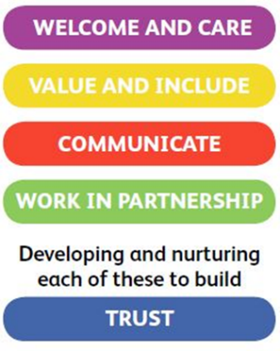

The Four Cornerstones

Genuine Partnerships is a nationally recognised Rotherham-based team of parent carers, service practitioners and young people modelling, promoting and strengthening co-production through their Four Cornerstones approach.

*Currently, *VOICES* packages are being delivered virtually in response to the COVID 19 pandemic. This will be regularly reviewed with local area partners as restrictions are eased.

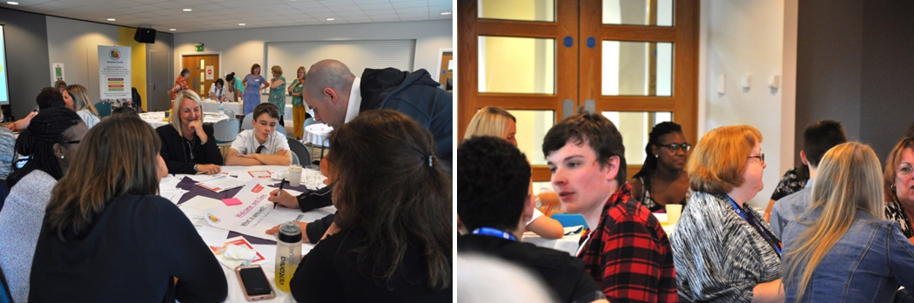

*“..we know what we need to aspire to! … so that co-production becomes a way of life”*

*“It was immensely helpful to have such a positive team working with us …”*

*‘’The work in Rotherham is inspiring.’’*

What difference will the full *VOICES* process make to your local area?

* Through a process of joint reflection and activity involving key SEND partners in your local area you will know how well you are doing when it comes to co-production
* You will have a report providing an evidence-base that authentically represents the voices of local young people, parent carers and practitioners to provide a basis for your next steps and action plan
* Building upon strengths, positive relationships and local area partnerships across sectors will have greater mutual understanding and co-production will strengthen within culture and ethos
* Most importantly, everybody’s experience should be enhanced

|  |
| --- |
| Full *VOICES* package: from £12,500 plus expenses  The package is co-delivered by a dedicated and experienced team of parent carers and/or young people together with practitioners. They will work in partnership with you to learn more about your local context and offer informal peer support, including consultations and communications, as you are planning. Focus groups will be facilitated, transcribed and analysed and key co-production narratives identified in a comprehensive report, including strengths and next steps. The team will then co-deliver a whole area co-production training and action planning event involving all key SEND partners at which priorities for the area will be agreed. |

Also ask about bespoke alternatives, costings for a graduated approach, consultation and training packages to suit your area’s needs.

Contact Eva for more details:

email genuine.partnerships@rotherham.gov.uk or telephone 01709 822580