Genuine Partnership Consultancy

and other options

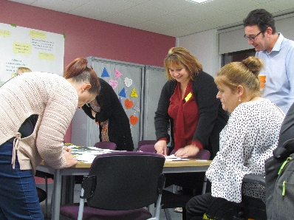Co-production is a particular way of working, unique to each context, and requires careful nurturing. You can’t simply plant one model of co-production and expect it to thrive, which is why it is so hard to replicate. But you’re not alone. Every Local Area has a responsibility under section 19 of the Children and Families Act 2014, and in considering their Ofsted / CQC joint Local Area inspection, to face this question.

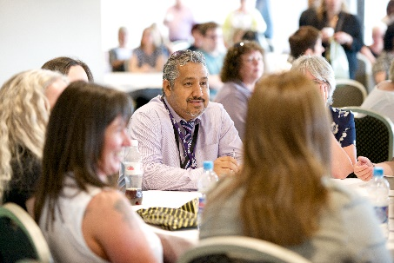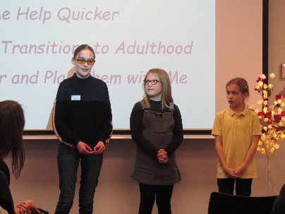

The good news is that the Genuine Partnerships team can help by offering consultancy support and/or a range of other bespoke options to meet the needs of your local area.

Genuine Partnerships is a nationally recognised Rotherham-based team of parent carers, service practitioners and young people modelling, promoting and strengthening co-production and inclusion within local areas through their Four Cornerstones approach.

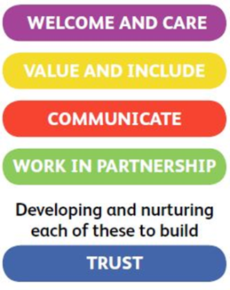

The Genuine Partnerships model is built around the Four Cornerstones of

Co-production and Inclusive Practice

What difference will the Genuine Partnerships team make to your local area?

* Better understanding of how well your local area is doing when it comes to co-production
* Guidance in involving all key SEND partners, particularly parent carers and young people but also Education, Health and Care partners, in devising your co-production next steps action plan
* Greater mutual understanding, strengthened relationships and more meaningful partnership working

“It was immensely helpful to have such a positive team working with us …”

Genuine Partnerships Consultancy daily rate: £750 plus expenses

Contact Eva for more information or to ask about alternative bespoke options:

email genuine.partnerships@rotherham.gov.uk or telephone 01709 822580